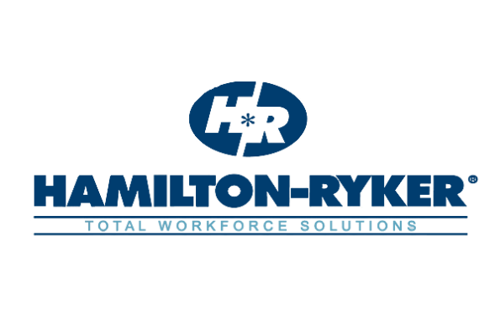

For Immediate Release
HAMILTON-RYKER WINS CLEARLYRATED’S 2020 BEST OF STAFFING CLIENT DIAMOND AWARD FOR SERVICE EXCELLENCE
Franklin, TN, February 18, 2020 –Hamilton-Ryker, a Total Workforce Solutions provider and leading staffing agency has won the Best of Staffing Client Diamond Award for providing superior service to their clients. Winners who earned the Diamond Award distinction have won the Best of Staffing Award for at least 5 years in a row, consistently earning industry-leading satisfaction scores from their clients.

On average, clients of winning agencies are 3.3 times more likely to be completely satisfied with the services provided compared to those working with non-winning agencies. Hamilton-Ryker received satisfaction scores of 9 or 10 out of 10 from 72.3% of their clients, significantly higher than the industry’s average of 24%.

“Winning this award proves that our clients value our support and see that we are keeping true to our small-town values by delivering exceptional customer service,” said President and CEO Kelly McCreight. “We truly strive to develop a partnership with our clients, which is based on open communication and trust.”
The award came just as Hamilton-Ryker began celebrating the 49th “birthday” of the company, which was started in 1971. When they first started as West Tennessee Personnel Services in a small building in Martin, TN, the founders’ vision was to just make enough money to keep the lights on. Forty-nine years later, as corporate staff move into a new state-of-the-art facility and with offices that stretch from Washington DC to San Marcos, TX, the company that the founders started now services a variety of industries and employs over 10,000 people each year.
“We employ a wide range of positions — from forklift drivers to IT specialists to oil and gas engineers. Our core services of staffing and recruiting have expanded to Workforce Development, Vendor Management Services and Managed Service Provider solutions, as well as IT managed services for the Federal government in Washington DC. “added McCreight.
About Hamilton-Ryker
Hamilton-Ryker is a Total Workforce Solutions company and award-winning industry leader that helps address today’s workforce challenges. For more information, visit www.hamilton-ryker.com .
About ClearlyRated
ClearlyRated utilizes a Net Promoter Score survey program to help professional service firms measure their service experience, build online reputation, and differentiate on service quality. ClearlyRated's Best of Staffing® Award is the only award in the U.S. and Canada that recognizes staffing agencies that have proven superior service. Learn more at https://www.clearlyrated.com/solutions/ .
Contact
Eddie Martinez
Marketing Manager
(615) 291-2026
emartinez@hamilton-ryker.com

